**Practical – 3**

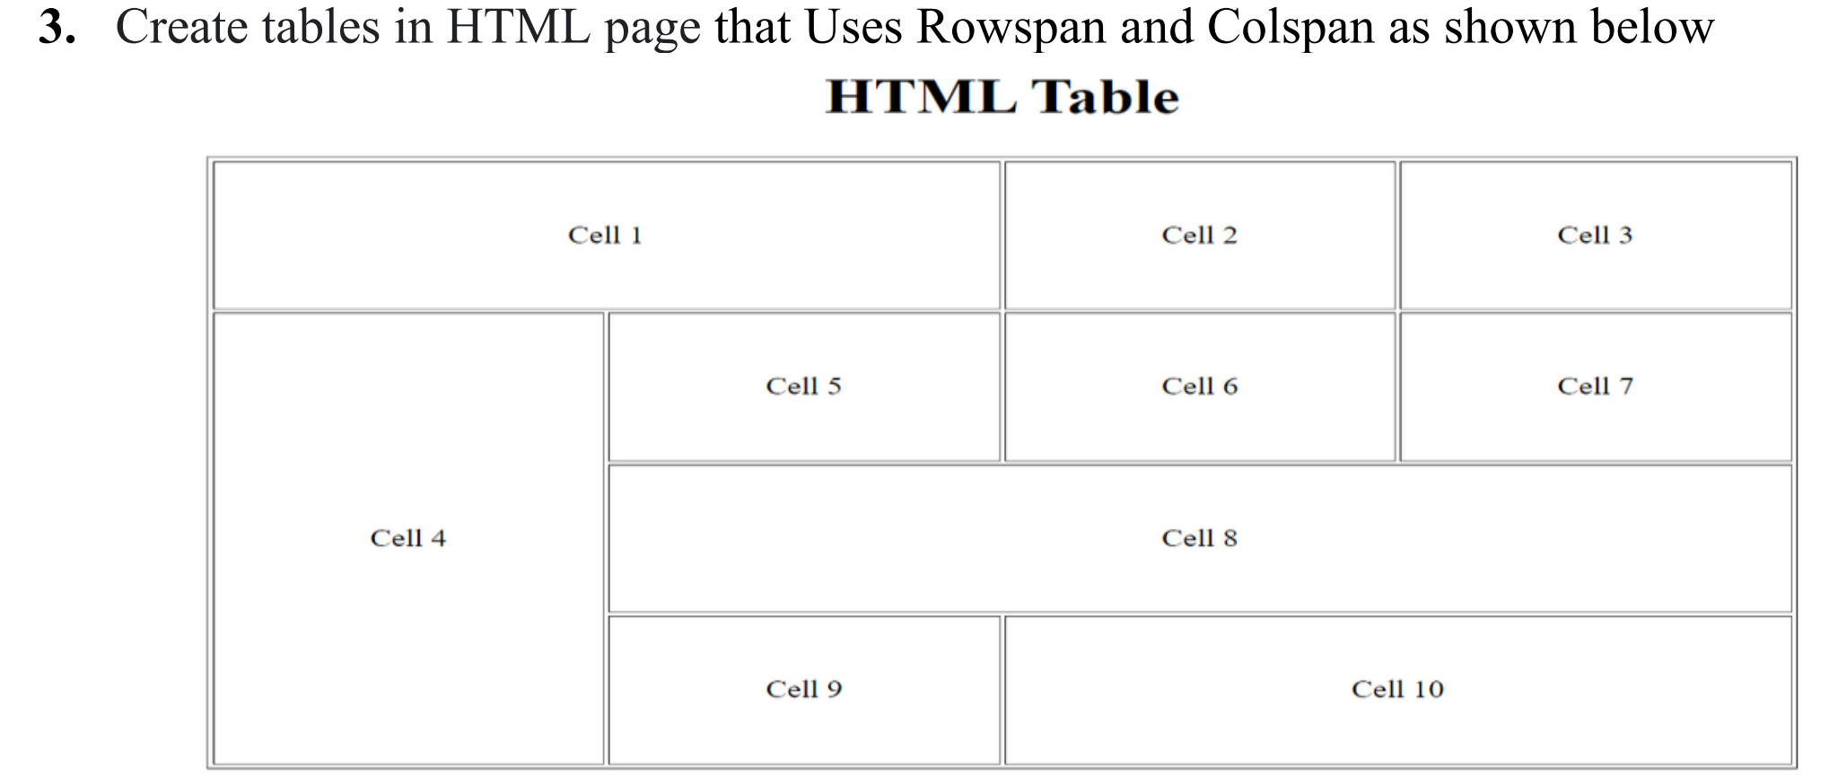

**HTML Code**

<!DOCTYPE html>

<html lang="en">

<head>

<meta charset="UTF-8">

<meta name="viewport" content="width=device-width, initial-scale=1.0">

<title>Rowspan & Colspan </title>

</head>

<body>

<center>

<table border="1" height="400px" width="800px" style="text-align: center;">

<caption>HTML Table</caption>

<tr>

<td colspan="2">

Cell 1

</td>

<td>Cell 2</td>

<td>Cell 3</td>

</tr>

<tr>

<td rowspan="3">Cell 4</td>

<td>Cell 5</td>

<td>Cell 6</td>

<td>Cell 7</td>

</tr>

<tr>

<td colspan="3">Cell 8</td>

</tr>

<tr>

<td>Cell 9</td>

<td colspan="2">Cell 10</td>

</tr>

</table>

</center>

</body>

</html>

**Output**

